

Blessed Trinity R.C. College

GCSE Examination Timetable

Summer 2026


INFORMATION FOR PUPILS
GCSE EXAMINATIONS 2026

REGULATIONS – MAKE SURE YOU UNDERSTAND THE RULES

- Make sure that you check your exam timetable carefully every day during the exam period. It is no use arriving in the afternoon for a morning examination – you cannot sit the exam at any other date or time. If you are late, your work might not be accepted. If for any reason you are delayed or sleep in and will be late for an exam, you should ring the school and inform the office. The school telephone number is 01282 506200.
- The cost of external examination entry to the school is enormous; the 2026 fee is approximately
£50.00 per subject exam. If you fail to appear for any exam you will be charged the entry fee unless you are ill and obtain a sick note from your doctor. It is only with this evidence that we may be able to make a representation for a grade on your behalf. This must be given to Mr. Geoghegan, Examinations Officer.
- Pupils should inform Mr. Geoghegan, Examinations Officer, or the attendance office of any change of circumstances immediately e.g. injuries or illness.
4. On exam days you should ensure that you arrive to school promptly. Morning exams usually start at 9.00am and afternoon exams at 1.15pm. All pupils are expected to attend their form registration each day and this is non-negotiable. Pupils must not miss form at any point during the examination period.

- Most exams will take place in the SOS sports hall. You will receive an individual timetable which gives information on dates, times and seat number. Seating Plans will be clearly displayed outside the Theatre and the SOS.

WATCHES, MOBILE PHONES, IPODS, MP3/4 PLAYERS OR ANY OTHER PRODUCTS WITH TEXT/DIGITAL FACILITIES, MUST NOT BE TAKEN INTO EXAMS. Notes, calculator cases/instruction leaflets and reading pens are also not allowed in an exam venue. Candidates will be given no credit for exams in which they are found to be in possession of any of the above. This could result in no grade being awarded for that GCSE.

- Pupils must not communicate with or disturb another candidate after they have entered the exam room. You must not become involved in any unfair or dishonest practice during the exam and if you try to cheat, or break the rules in any way, you could be disqualified from all your subjects.

- Pupils must ensure that they write their legal name on all examination papers. Pupils must not write inappropriate, obscene, or offensive material on their examination papers.

- The school has in place policies regarding; GCSE (or equivalent) Assessment Decisions and Appeals Policy (GCSE controlled and NEA assessment). These are available on request.

FULL SCHOOL UNIFORM MUST BE WORN ALWAYS.

MAKE SURE YOU BRING WHAT YOU NEED
All equipment will be provided for you during the examinations. If you choose to bring your own, you must ensure that it is contained in a clear pencil case with no labels. If you choose to bring a drink, it MUST be contained in a clear bottle with ALL labels removed.

INSTRUCTIONS DURING AND AT THE END OF THE EXAM

  - Regulations regarding conduct in exams will be displayed both inside and outside the halls. Read these carefully. Candidates ARE NOT allowed to leave exams before the scheduled finishing time.
  - During the exam you must listen to the invigilator and follow their instructions always.
  - Make sure you read through and follow the instructions printed on the question paper/answer booklet.
  - If you think you may have been given the wrong question paper or all the materials needed for the exam, put your hand up and inform one of the invigilators.
  - Remember to write your answers in the correct places in the answer booklet. Do all your rough work in the answer booklet and cross through anything you don’t want marking.
  - If you use any additional stationery, make sure that you write on your name and candidate number.
  - Put your hand up during the exam if you have a problem, you feel ill, you need more paper or equipment.
  - You must not ask for, and will not be given, any explanation of the questions.
  - If you need to leave the exam room during the examination, you must be accompanied by an invigilator.
  - Do not leave the exam room until told to do so and you cannot take from the room any stationery, this includes question papers, answer booklets and any rough work.

AFTER THE EXAMINATIONS – RESULTS DAY
Results are expected in school on Thursday 20th August 2026. Results can be collected from the school and details will be sent out regarding results day, nearer the time. If you are unable to collect your results at this time, you can ask a member of your family only to collect on your behalf, but they will need to bring a signed letter from yourself giving permission to do so. After this time, results will be available when the college reopens in September.



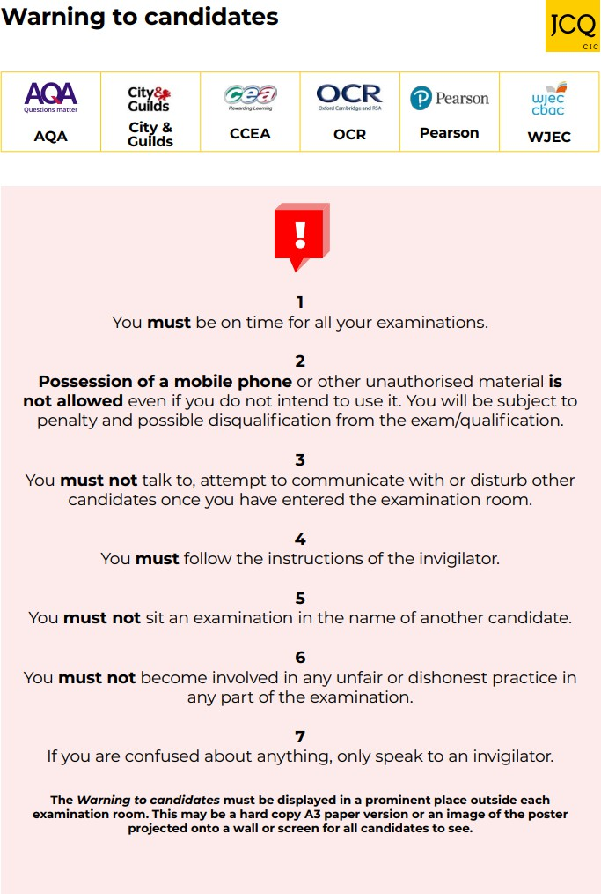

Below is the Summer 2026 GCSE timetable
Pupils will be given an individual, finalised timetable which will include arrangements for any clashes.
The first written exam is on 6th May and students must be available until the final contingency day, which is 25th June, even if their last exam is earlier than this.

*CLASHES:

The following clashes occur during this exam period. All pupils that this affects will be spoken to individually about the arrangements for this.
19/05/2026 PM Urdu/PE/IT

20/05/2026 PM Sociology/Computing 2

10/06/2026 AM Spanish/ Sports & Coaching

All MFL speaking exams take place between 29th April to 2nd May (French, Spanish, Urdu, Polish, Russian).
The ART examination will take place on 24th and 25th April.
The PHOTOGRAPHY exam will take place on 30th April and 1st May.

These will NOT show on your exam timetable as they are internal exams.

GCSE Exams Summer 2026 Week 1 – WEEK B

Monday | Tuesday | Wednesday | Thursday | Friday
4th May | 5th May | 6th May | 7th May | 8th May
9:00 | 9.00 | 9.00 | 9.00 | 9.00
 | EDEXCEL |  |  | AQA  GCSE  Sociology Paper 1  1hr 45
 | BTEC |  |  | AQA  GCSE  Sociology Paper 1  1hr 45
 | Health and Social Care |  |  | AQA  GCSE  Sociology Paper 1  1hr 45
 | 2h |  |  | AQA  GCSE  Sociology Paper 1  1hr 45
1.15 | 1.15 | 1.15 | 1.15 | 1.15

GCSE Exams Summer 2026 Week 2 – WEEK A

Monday | Tuesday | Wednesday | Thursday | Friday
11th May | 12th May | 13th May | 14th May | 15th May
9.00 | 9.00 | 9.00 | 9.00 | 9.00
AQA  GCSE  English Literature Paper 1  1h 45m | WJEC  GCSE  Religious Studies B  Foundational Catholic Theology  Paper 1  1h 30m | AQA  GCSE  Geography Paper 1  1h 30m | EDEXCEL GCSE  Mathematics Paper 1  (Non-Calculator)  1h 30m | AQA  GCSE History  Paper 1B Option A  2 h  *NB: 2 separate papers take place in this session
1.15 | 1.15 | 1.15 | 1.15 | 1.15
 | AQA  GCSE  Combined Science: Trilogy Combined Science: Trilogy - Biology Paper 1 (both tiers)  1h 15m  AQA GCSE  Biology  Biology Paper 1 (both tiers)  1h 45m | EDEXCEL  GCSE  Computer Science  Written Paper  1h 30m |  | AQA  GCSE  Sociology Paper 2  1hr 45  OCR  GCSE  Information Technology  1 h 30

GCSE Exams Summer 2026 Week 3 – WEEK B

Monday | Tuesday | Wednesday | Thursday | Friday
18th May | 19th May | 20th May | 21st May | 22nd May
9.00 | 9.00 | 9.00 | 9.00 | 9.00
AQA GCSE  Combined Science: Trilogy Combined Science: Trilogy - Chemistry Paper 1 (both tiers)  1h 15m  AQA GCSE  Chemistry  Chemistry Paper 1 (both tiers)  1h 45m | AQA GCSE  English Literature  Paper 2  2h 15m | AQA GCSE  French Listening (F & H) French Paper 1  35m / 45m  AQA GCSE  French Reading (F & H) French Paper 3  45m / 1h | WJEC GCSE  English Language  20TH Century  Paper 1  1h 45m | EDEXCEL GCSE  P.E. Fitness and Body systems  Paper 1  1h 30  AQA GCSE  Italian Listening H 45m  Reading H 1h  AQA GCSE  Arabic Listening H 45m  Reading H 1h 5m
1.15 | 1.15 | 1.15 | 1.15 | 1.15
AQA GCSE  Urdu Listening F 35m H 45m  Reading F 45 m H 1h | EDEXCEL GCSE  Computer Science  Practical Paper 2  2h | WJEC GCSE  Religious Studies B  Applied Catholic Theology  Paper 2  1h 30

GCSE Exams Summer 2026 Week 4 – WEEK A

Monday | Tuesday | Wednesday | Thursday | Friday
1st June | 2nd June | 3rd June | 4th June | 5th June
9.00 | 9.00 | 9.00 | 9.00 | 9.00
EDEXCEL GCSE  P.E. Health and Performance  Paper 2  1h 15  AQA GCSE  Italian Writing  H 1 h 15 | AQA GCSE  Combined Science: Trilogy Combined Science: Trilogy - Physics Paper 1 (both tiers)  1h 15m  AQA GCSE  Physics  Physics Paper 1 (both tiers)  1h 45m | EDEXCEL GCSE  Mathematics Paper 2  (Calculator)  1h 30 | AQA  GCSE  History Option A  Paper 2A  History Option C  Paper 2B  2h  *NB: 2 separate papers take place in this session | WJEC GCSE  English Language (non-fiction)  Paper 2  2h
1.15 | 1.15 | 1.15 | 1.15 | 1.15
WJEC GCSE  Religious Studies B  Applied Catholic Theology  Paper 3  1h | AQA GCSE  Polish Listening F 35m H 45m  Reading F 45m H 1h  Russian Listening F 35m H 45m  Reading F 45m H 1h  AQA GCSE  Urdu Writing F 1h H 1h 15  Arabic Writing F 1h H 1h 25 | AQA GCSE  Geography  Paper 2  1h 30m | AQA GCSE  French Writing (F & H)  1h / 1h 15m | WJEC GCSE  Music  1h 30m

GCSE Exams Summer 2026 Week 5 – WEEK B

Monday | Tuesday | Wednesday | Thursday | Friday
8th June | 9th June | 10th June | 11th June | 12th June
9.00 | 9.00 | 9.00 | 9.00 | 9.00
AQA GCSE  Combined Science: Trilogy Combined Science: Trilogy - Biology Paper 2 (both tiers)  1h 15m  AQA GCSE  Biology  Biology Paper 2 (both tiers)  1h 45m | AQA GCSE  Spanish Listening (F & H)  35m / 45m  AQA GCSE  Spanish Reading (F & H)  45m / 1h | EDEXCEL  GCSE  Mathematics Paper 3  (Calculator)  1h 30m | AQA GCSE  Geography  Paper 3  1h 30m | AQA GCSE  Combined Science: Trilogy Combined Science: Trilogy - Chemistry Paper 2 (both tiers)  1h 15m  AQA GCSE  Chemistry  Chemistry Paper 2 (both tiers)  1h 45m
1.15 | 1.15 | 1.15 | 1.15 | 1.15
AQA  Further Mathematics  Paper 1  1hr 45m | WJEC GCSE  Sports & Coaching  Unit 1  1hr 20 | AQA GCSE  Design and Technology  2h  AQA GCSE  Russian Writing H  1hr 25m | NCFE  Level 1 2 Music Technology | AQA GCSE  Polish Writing H  1h 15m  WJEC  Hospitality and Catering Unit 1 1h 20m

GCSE Exams Summer 2026 Week 6 – WEEK A

Monday | Tuesday | Wednesday | Thursday | Friday
15th June | 16th June | 17th June | 18th June | 19th June
9.00 | 9.00 | 9.00 | 9.00 | 9.00
AQA GCSE  Combined Science: Trilogy Combined Science: Trilogy - Physics Paper 2 (both tiers)  1h 15m  AQA GCSE  Physics  Physics Paper 2 (both tiers)  1h 45m | AQA GCSE  Spanish Writing (F & H)  1h / 1h 15m
1.15 | 1.15 | 1.15 | 1.15 | 1.15
AQA
Further Mathematics
Paper 2
1hr 45m

11th June (afternoon) & 25th June (all day) – Contingency Days

